William R Davis Artist Material List
Workshops

Most Common Colors to be used in the workshop:
All of these colors can be bought at Utrecht
or at Jerry's Artarama
My prefered brands of paint is Gamblin or Rembrandt .
White (blend 50% zinc & 50% Titanium)
Ivory Black
Sepia (optional) I use this often as my black (Rembrandt best)
Yellow Ochre
Cadmium Yellow Deep
Cadmium Yellow Light
Cadmium red (medium)
Venetian or Indian Red
Raw Umber
Greenish Umber (Rembrandt best)
Ultramarine Violet
Ultramarine Blue
Cobalt Blue
Cerulean Blue (expensive) (Cerulean Blue Hue can be used, it's cheaper but not quite as good)
Indigo Blue (optional)
Prussian Blue (optional) rarely used
Transparent Oxide Red (optional) but but used often in glazing, handy to have.
Transparent Oxide Yellow (I use a lot)
Dioxazine Purple
(I prefer to use no strong greens on my palette. I make my greens from blues. But please bring greens you may usually use)
Please Avoid Alkyds they dry too fast for soft brushing

Brushes:
Bristle Rounds: 0, 2, 4
Bristle Flats: 2, 4, 6,
Bristle Fan: 2, 4
Nylon Brights: 6, 10, 20
Nylon Rounds: 0, 1, 2, 4

Large Nylon Flats for soft brushing (see image below) available at almost all art & craft stores
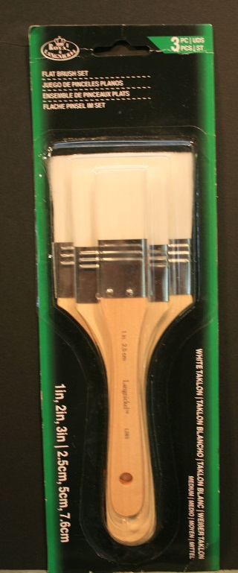
(I also have an assortment of more unusual brushes on site for personal use, I would prefer that you become accustomed to try using these before purchasing them for the workshop)

Medium:
Linseed oil or even better Cold Pressed Linseed Oil (any make will do)
(I use no varnish or turpentine in my medium)
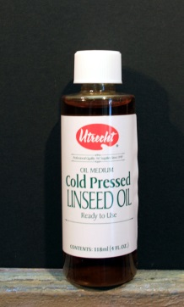

Brush cleaner I use Turpenoid Natural (low odor) but many artists still prefer regular turpentine
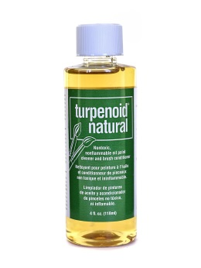

Palette Knives:
any Standard Medium

Preferred Painting Panels:
Either:
Acrylic Gesso primed canvas panels (these can be quite dry and usually poorly coated) If you use these, you may want to add a couple more gesso coats.
Acrylic Gesso primed hardboard panels
1/8 flats are best. you do not need cradled boards.
Jerry's Artarama has a good selection here: Gessobord
(best sizes for workshops are 6x8, 8x10, 9x12)

Easels
Indoor studio workshops usually have an assortment of easels available for use. They are not very expensive and stable with light wind.
Outdoor (Plein Air) it is recommended bringing a standup easel such as a French Easel or many types of pallette boxes that attach to camera tripods
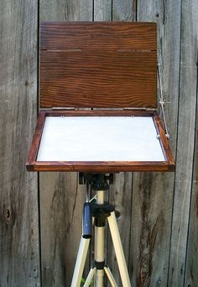

Have any other questions you can email me at: wrdfa@comcast.net

